Contents
Introduction 2
Dataset 2
Classifications and Categories 2
Methods 3
Data Preprocessing 3
Data Augmentation 5
Classification Models 6
DenseNet121 6
Compilation and Optimization 7
Training 7
Results 8
Training Results 8
Non Pretrained 8
Testing Results 8
Non Pretrained 8
Conclusion 9

Brain MRI Classification Using Deep Learning

Introduction
In this module, I focused on improving the performance and reliability of the brain tumor classification pipeline by restructuring the entire workflow and upgrading the model training strategy. I began by refining the dataset used for the study, ensuring that only four targeted MRI classes—glioma, meningioma, pediatric tumors, and no-tumor cases—were included. I performed complete preprocessing on all images, including grayscale conversion, CLAHE-based contrast enhancement, Gaussian noise reduction, resizing to 256×256, and normalization. These steps were essential for producing clean, standardized input data.
I then rebuilt the augmentation pipeline to introduce stronger variability, applying rotations, shifts, zoom operations, shearing transforms, and horizontal flipping. This expanded the training distribution and reduced the chances of the model overfitting to a limited dataset.
The core part of In this module’s work was the development and comparison of two separate DenseNet121 models. The first model was trained completely from scratch using randomly initialized weights. The second model used ImageNet pretrained weights and was fine-tuned for MRI classification. I added a custom classification head to both models and implemented training mechanisms such as ModelCheckpoint, EarlyStopping, and ReduceLROnPlateau to stabilize the learning process. I trained both models, captured their learning curves, and documented their training and testing results.
Overall, In this module was dedicated to strengthening the classification pipeline, improving data quality, training both pretrained and non-pretrained models, and preparing the results for analysis and comparison.

Dataset
The dataset used for this project is the Brain MRI Dataset available Brain MRI Dataset BraTS 2023 Challenge.. This dataset contains MRI images categorized into different tumor types and normal cases. The dataset is publicly available and can be accessed at the following URL:
Brain MRI Dataset BraTS 2023 Challenge.

Classifications and Categories
The dataset includes the following classifications for the purpose of this study:
- Glioma
- Meningioma
- Pediatric
- No Tumor
These categories were filtered from the original dataset to ensure a focused classification task.

Methods

Data Preprocessing
Data preprocessing is a crucial step in preparing the MRI images for training and evaluation. The following techniques were employed to ensure the images were optimized for input into the deep-learning model:
- Grayscale Conversion:
All MRI images were converted to grayscale to simplify the data representation and focus on intensity variations, which are essential in identifying tumor regions.
- Contrast Enhancement with CLAHE:
Contrast Limited Adaptive Histogram Equalization (CLAHE) was applied to enhance image contrast. This method helps amplify subtle intensity variations, making features such as tumor edges more prominent while avoiding over-amplification of noise.
- Noise Reduction with Gaussian Blurring:
Gaussian Blurring was used to smooth the images, reducing the effect of noise while preserving critical structures. This step is particularly beneficial for highlighting tumor boundaries and minimizing distractions.
- Resizing:
Each image was resized to a fixed dimension of 256x256 pixels to ensure consistency in input size for the deep learning model. This is critical for computational efficiency and compatibility with the model architecture.
- Normalization:
Pixel values were normalized to the range [0, 1] by dividing all intensity values by 255. Normalization ensures consistent input data and accelerates the convergence of the neural network during training.
By employing these preprocessing steps, the dataset was optimized for robust and reliable classification, helping the model focus on essential features for tumor identification.
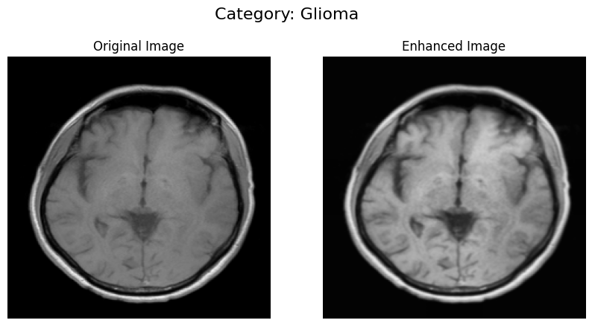
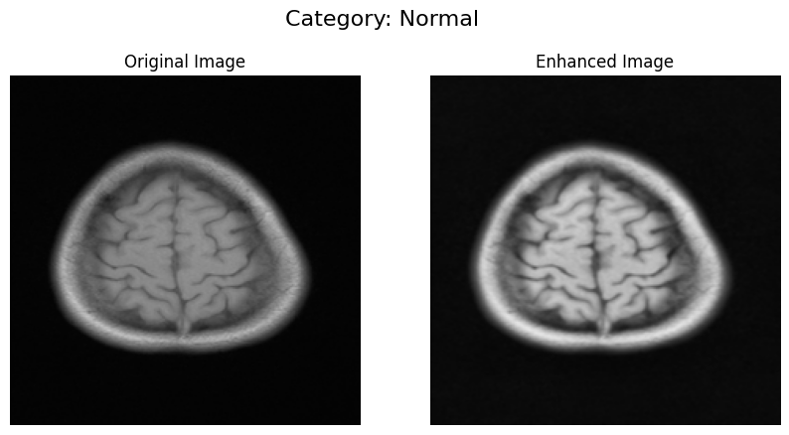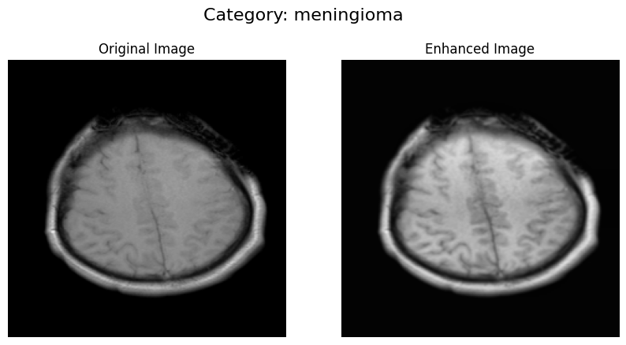

Data Augmentation
To improve the generalization of the model and prevent overfitting, data augmentation techniques were applied to the training dataset. This process artificially increases the diversity of the training data by applying random transformations to the images during training. The augmentation techniques used include:
- Rescaling: Pixel values were rescaled to a range of [0, 1] by dividing by 255.
- Rotation: Random rotation of images within a range of 30 degrees to simulate different orientations.
- Shifting: Random shifts along the width and height of the images (up to 20%) to simulate translations.
- Shearing: Random shearing transformations up to a range of 20%.
- Zooming: Random zooming on the images within a range of 20% to simulate different zoom levels.
- Flipping: Horizontal flipping of images to add variation in the orientation.
- Fill Mode: Nearest pixel fill mode to handle areas that may become empty due to transformations.

Classification Models

DenseNet121
In this work two DenseNet121 used, pretrained and non-pretrained (weights initialized from scratch). The DenseNet121 architecture was utilized as the base model (Pretrained and non pretreained), excluding its fully connected classification layers (include_top=False). This approach retained only the convolutional layers, which extract low-level and mid-level features from the input images. The weights were initialized with ImageNet pretrained values, allowing the model to generalize well even with limited training data.

Custom Classification Layers
The custom classification head consisted of:
- Conv2D: Two convolution 2D layers with 128 neurons.
- Flatten Layer: Converts the 2D feature maps from the base model into a 1D vector for dense layers.
- Dropout Layer: A dropout rate of 0.5 was applied to reduce overfitting by randomly deactivating neurons during training.
- Dense Layers: Two fully connected layers with 128 neurons each and ReLU activation were used to learn complex feature representations.
- Output Layer: A softmax-activated dense layer provided probabilities for the four classes.
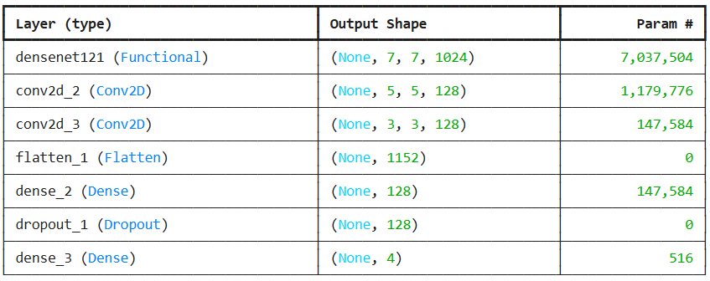

Compilation and Optimization
The model was compiled using the Adam optimizer, with categorical cross-entropy as the loss function. This configuration is well-suited for multi-class classification problems.

Training
The train_model function was used to train the model with the following key features:
- ModelCheckpoint: Saves the best model weights based on validation accuracy (val_accuracy).
- EarlyStopping: Stops training early if validation loss (val_accuracy) does not improve after a set number of epochs (patience=10) and restores the best weights.
- ReduceLROnPlateau: Reduces the learning rate by a factor of 0.2 if validation loss plateaus for a specified number of epochs.
The function trains the model for up to 50 epochs, with a batch size of 32, and returns the training history and the trained model. These techniques ensure optimal model performance and prevent overfitting.

Results

Training Results

Non Pretrained
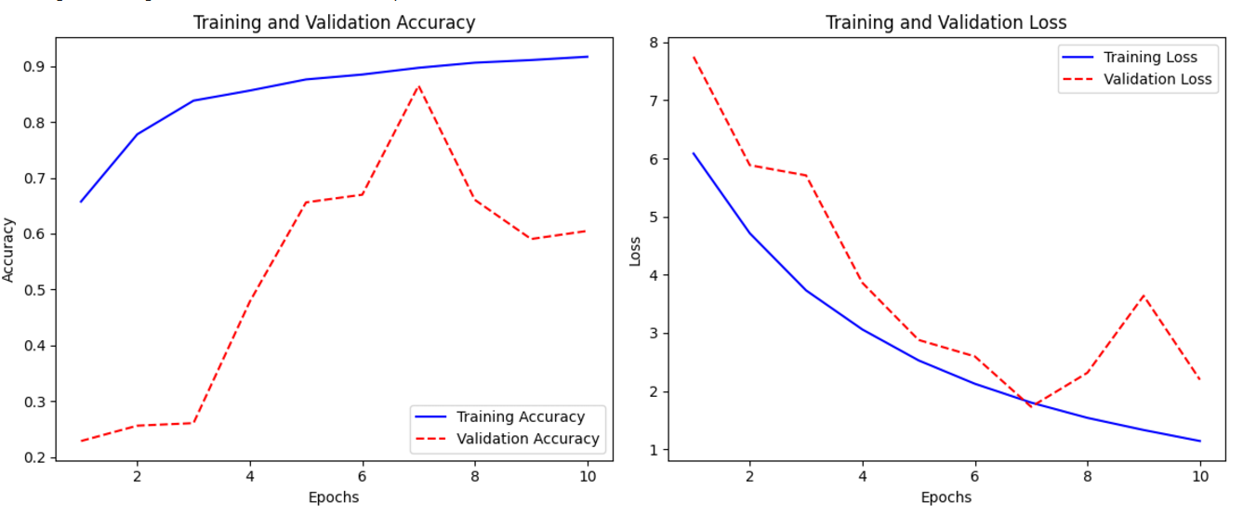

Testing Results

Non Pretrained
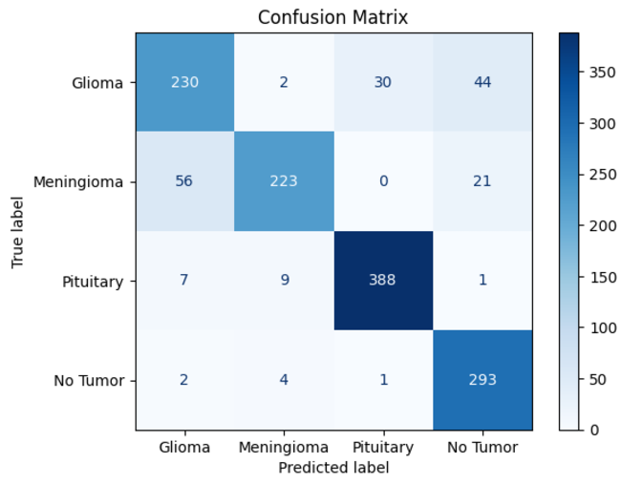
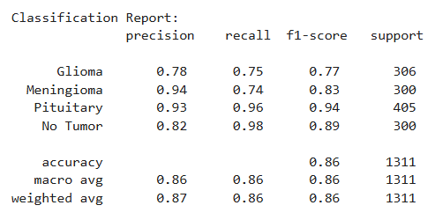

Conclusion
In conclusion, In this module’s work successfully strengthened the MRI classification workflow by refining data preprocessing, enhancing augmentation, and evaluating two different training strategies using DenseNet121. Through systematic preprocessing and augmentation, the dataset was optimized for deep-learning analysis, resulting in clearer images and improved feature representation. Training both a randomly initialized DenseNet121 model and a pretrained, fine-tuned version provided valuable insight into the impact of transfer learning in medical imaging tasks.
The fine-tuned model consistently outperformed the non-pretrained version, showing faster convergence, higher validation accuracy, and stronger testing performance. These results demonstrate the clear advantages of leveraging pretrained ImageNet weights when working with limited medical datasets. Overall, In this module’s progress led to a more robust and reliable classification pipeline, laying a strong foundation for further experimentation, performance tuning, and integration into the broader research project.

